**Module 3 Lab 1: Implementing MongoDB Operations in Node.js**

Naga Sumanth Vema

IFT 554: Middleware Programming & Database Security

Dinesh Sthapit

February 18th, 2024

**Module 3 Lab 1: Implementing MongoDB Operations in Node.js**

Screenshot 1: Of the config.env file showing the added environment variables.

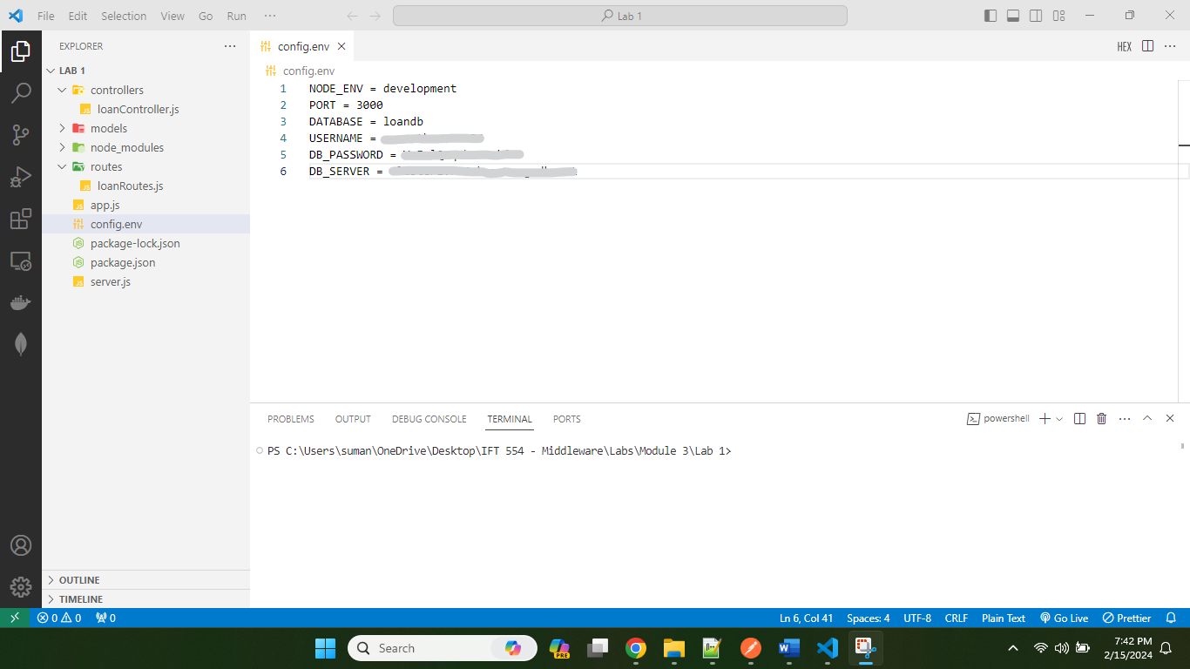

Step 2: Create Express Backend and Interact with Mongo

loanModel.js

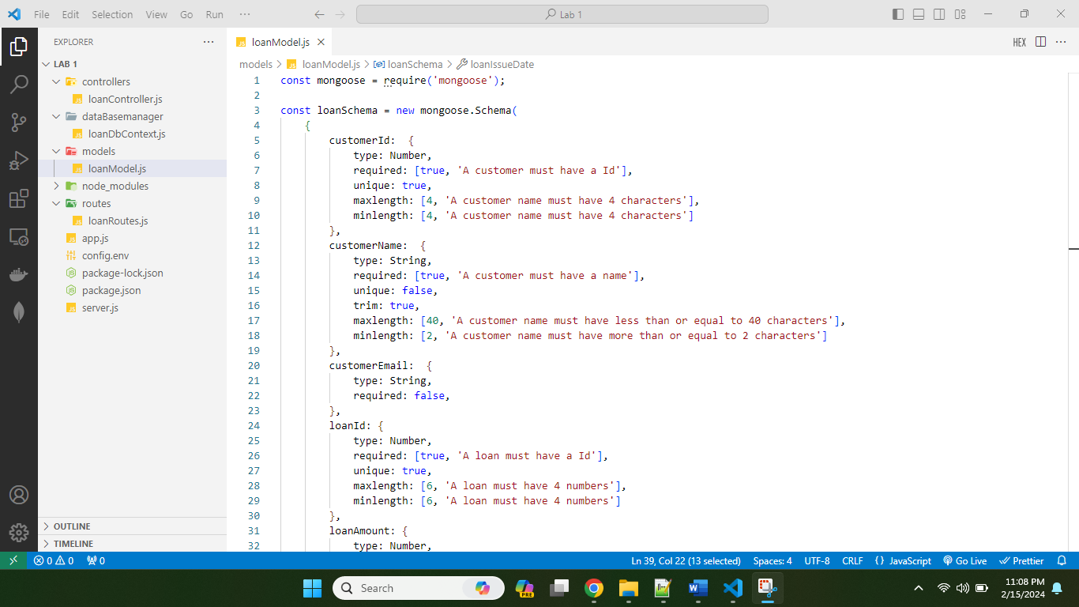

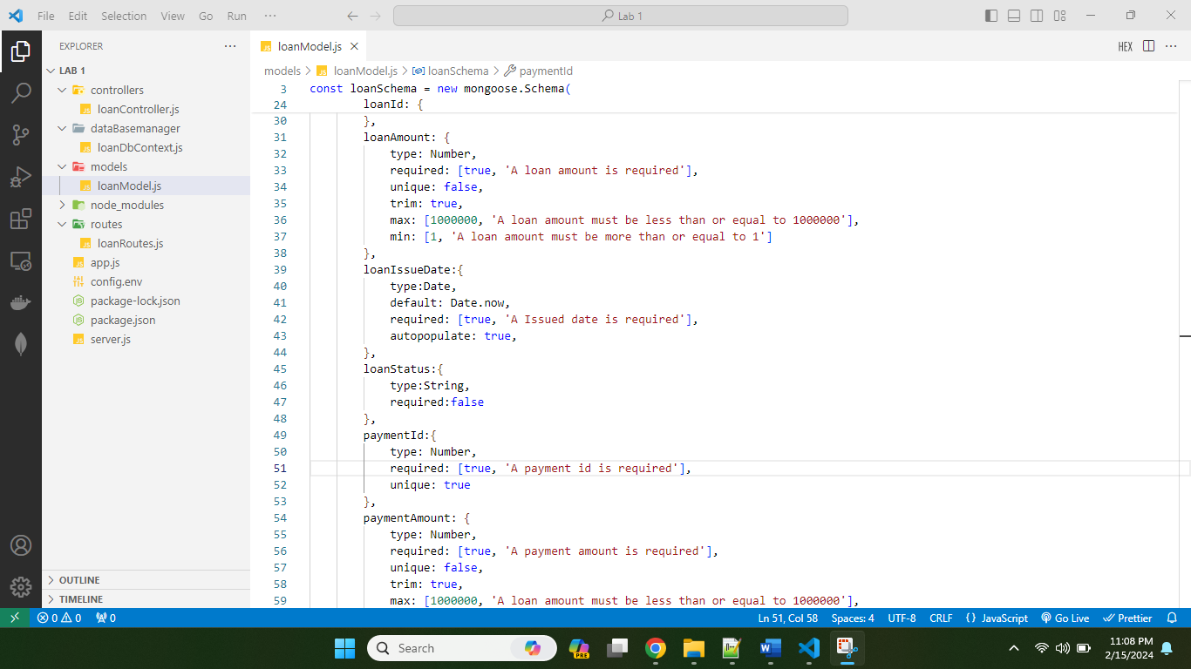

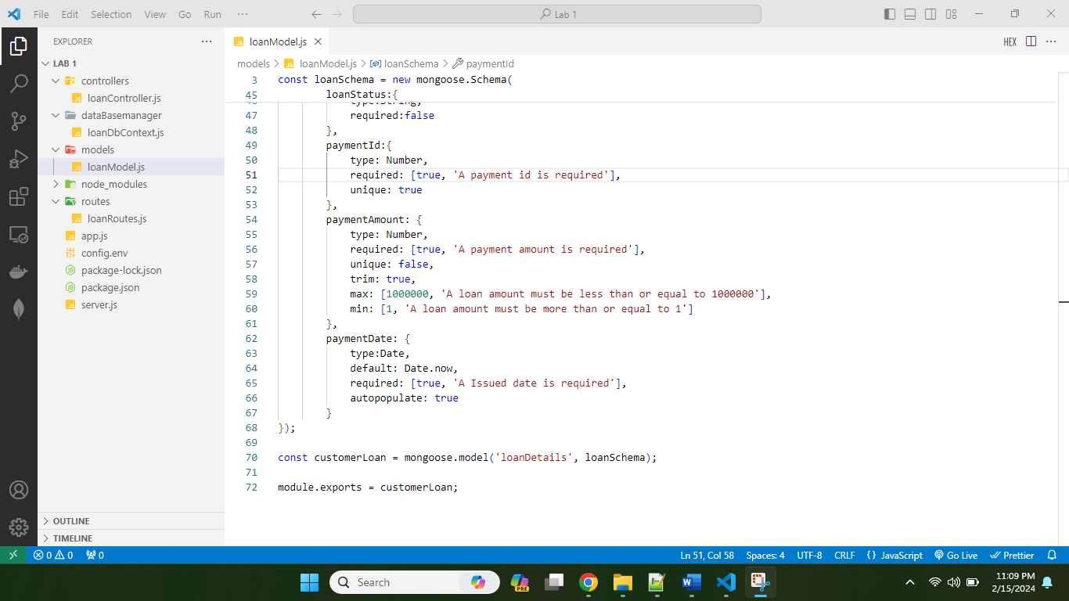

loanRoutes.js

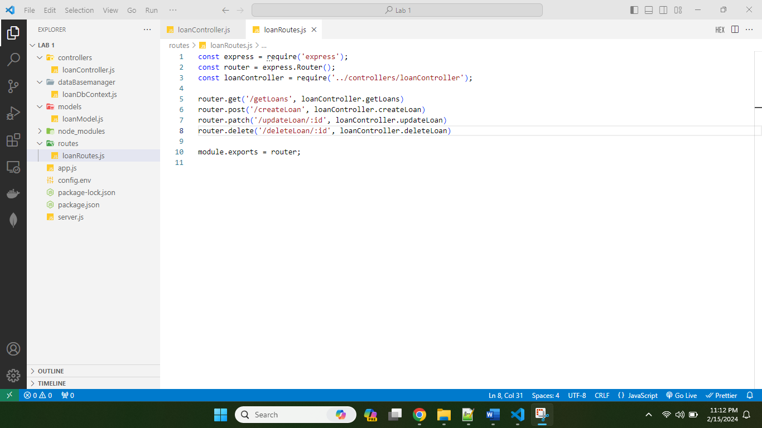

Server.js File:

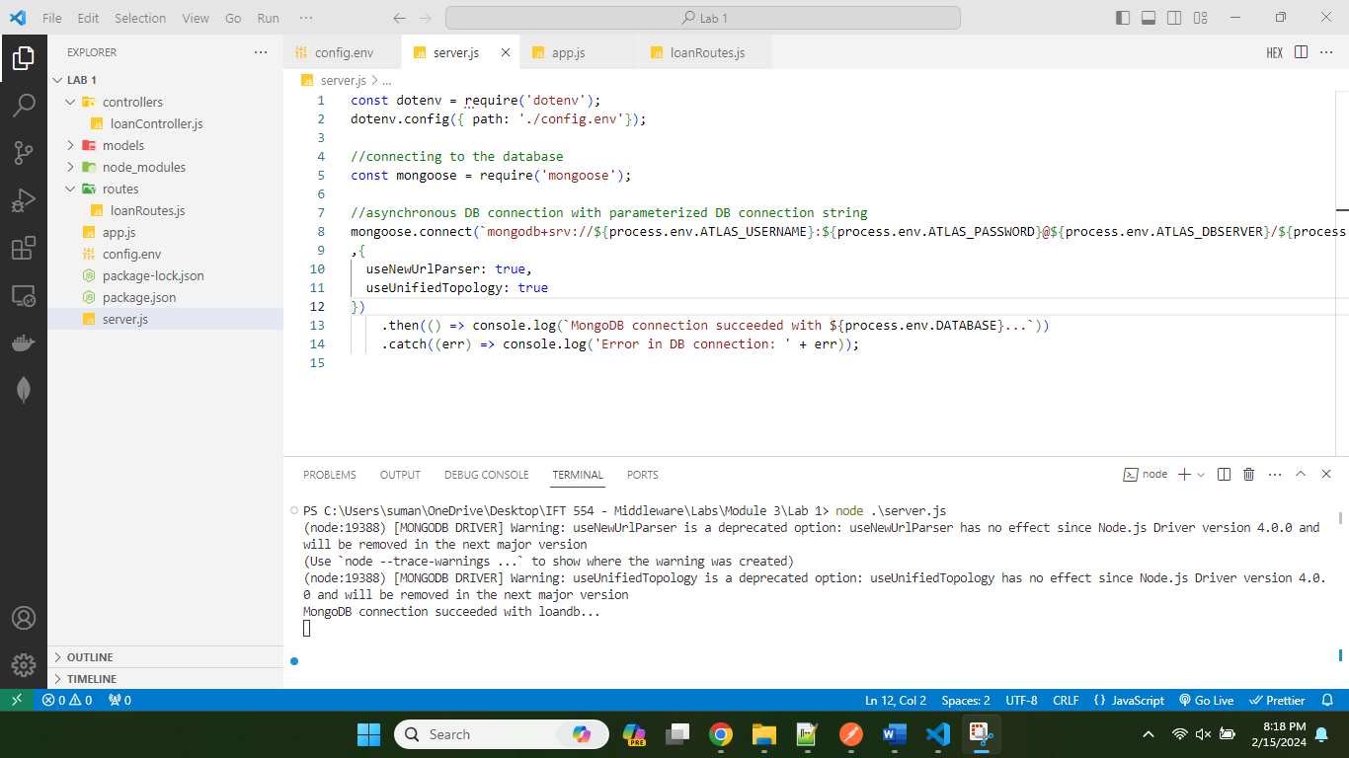

Screenshot 4: Of the loanDbContext.js file within the dataBaseManager folder showing the modified code.

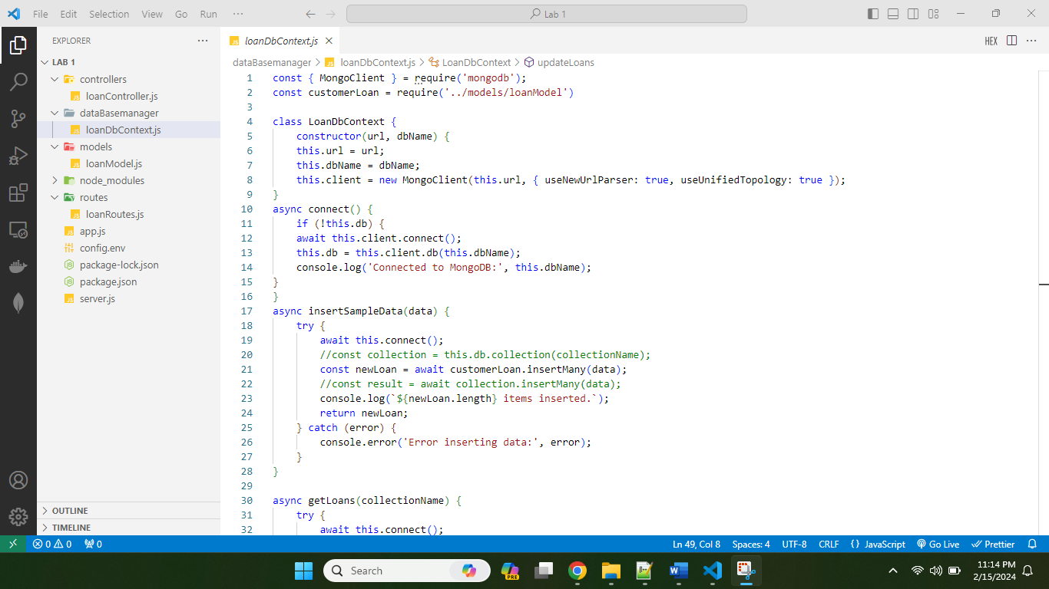

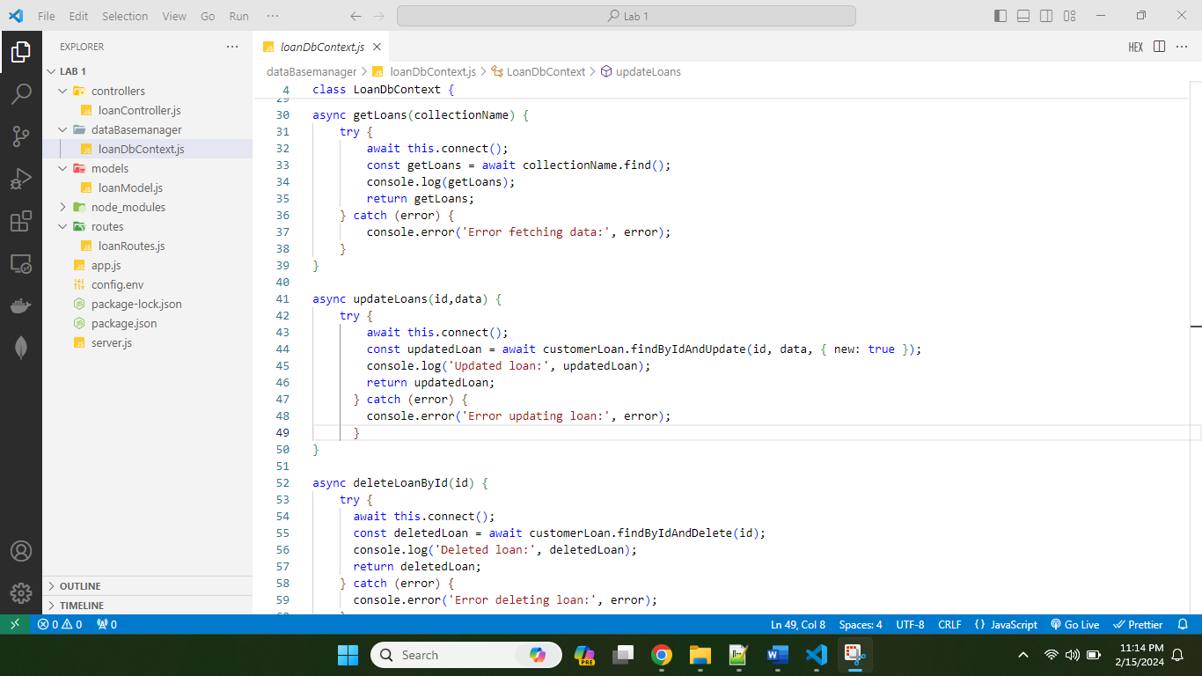

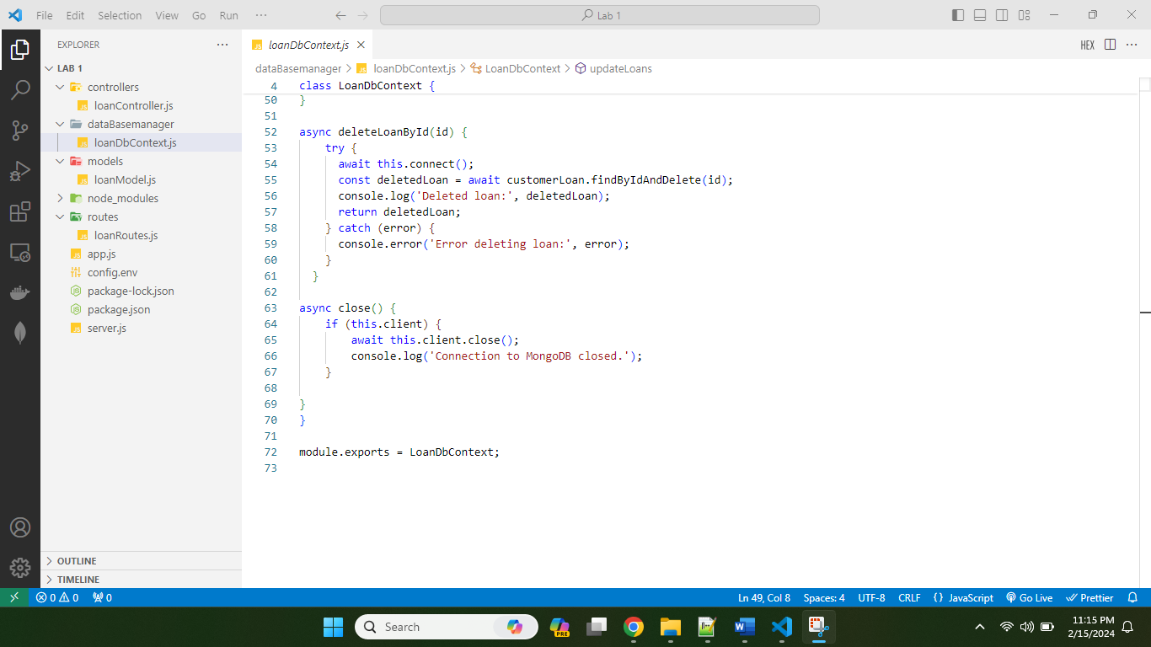

Screenshot 5: Of the updated loanController.js showing the controller logic.

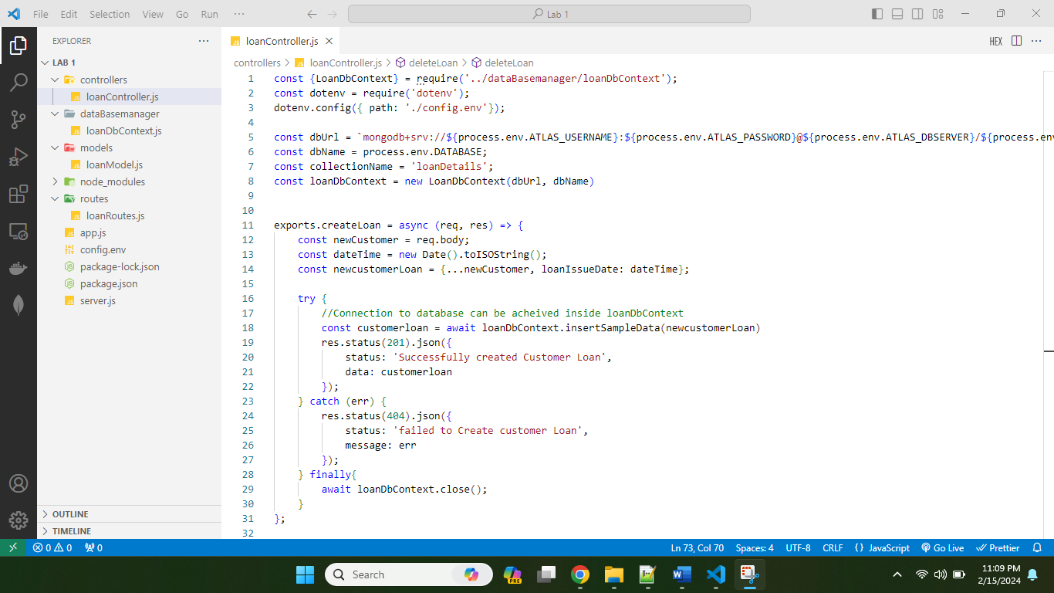

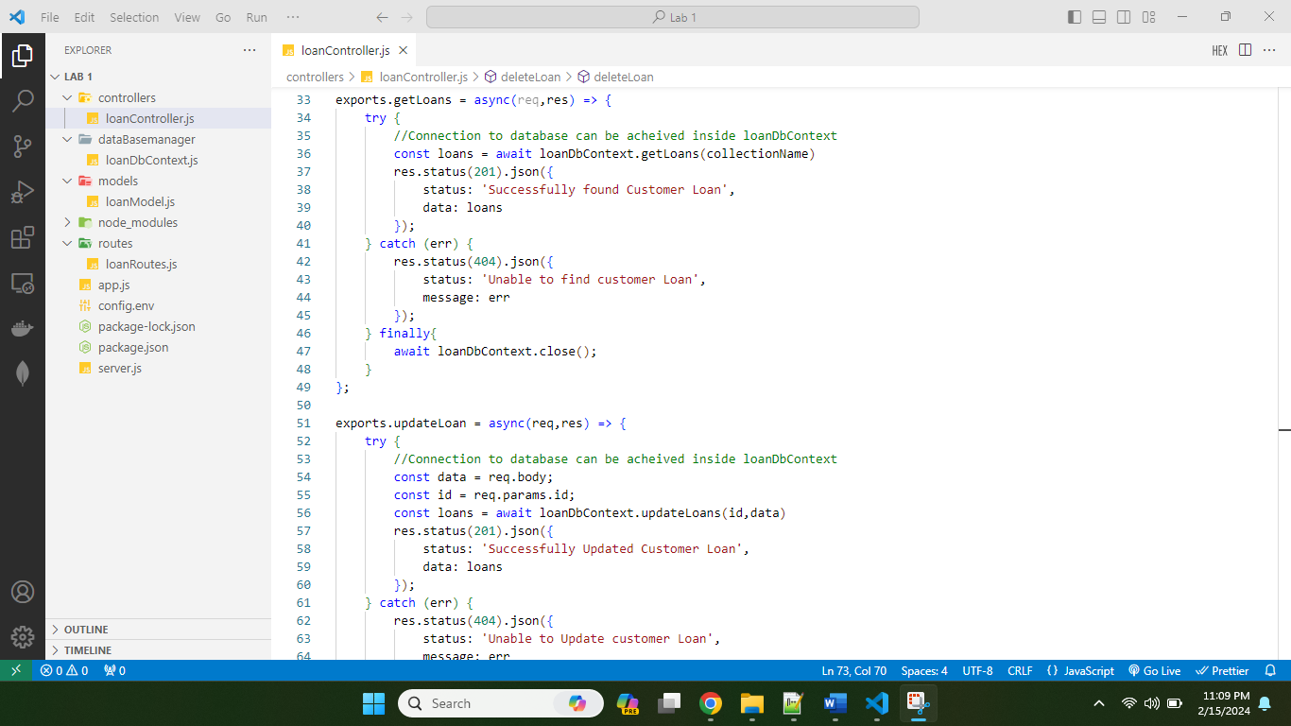

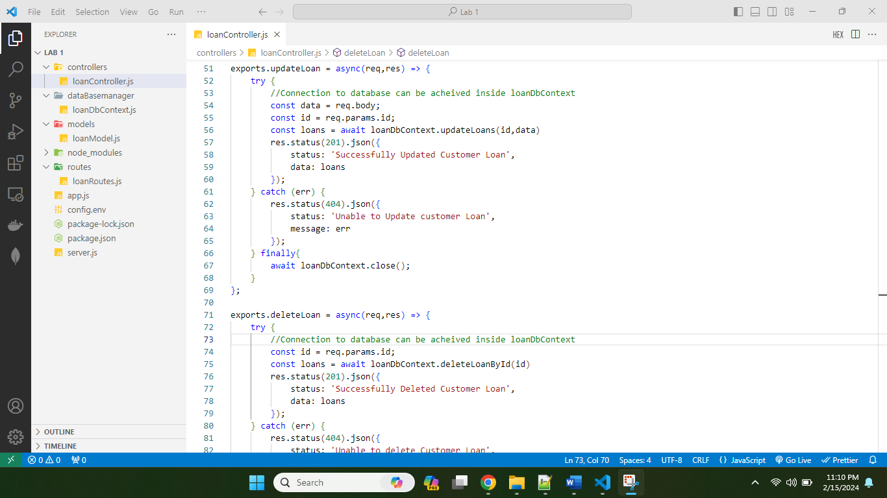

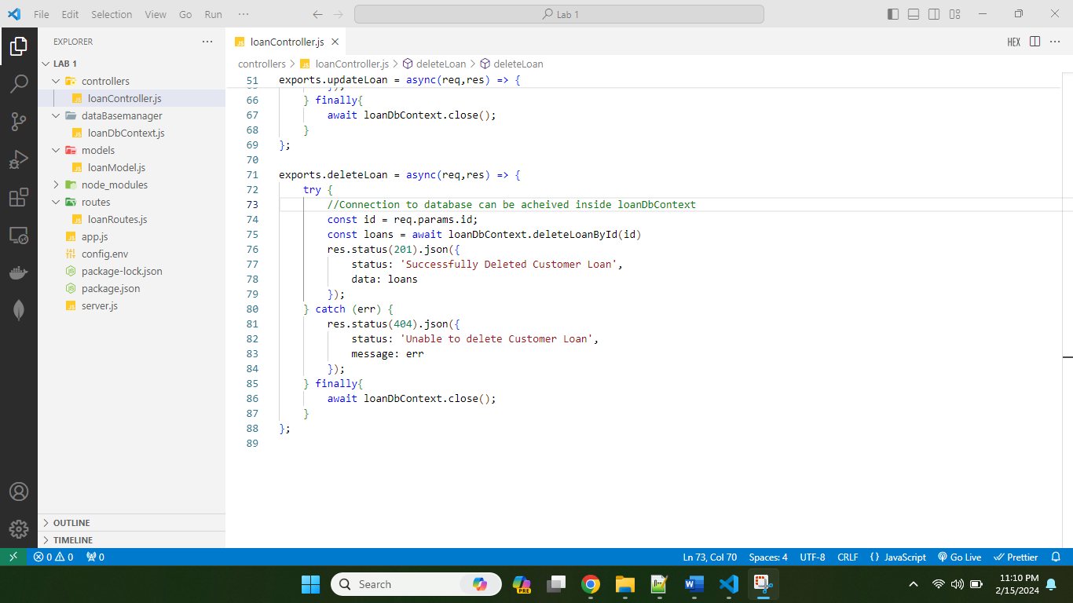

Screenshot 6: Of the app.js file showing the new routes and their configuration.

